Synergi Enterprise Performance Management

Installation Procedures

(CRS Integration)

Contents

Version History 2

Related Documents 2

Overview 3

Environment Setup 3

Installation Package Content 3

Installation Steps 3

Database Installation 3

Database Configuration 4

Website Installation 4

CompetitorWebServices Installation 5

Background Services Installation 5

Background Services Upgrade 6

CompetitorEngine Installation 6

CompetitorEngine Upgrade 6

After Installation 6

# Version History

|  |  |  |
| --- | --- | --- |
| **Version** | **Date** | **Change Summary** |
| 1.0 | 29-04-2013 | Document Created |
| 1.1 | 30-05-2013 | Document Updated |
| 1.2 | 01-11-2013 | Document Updated for CRS Integration |
|  |  |  |

# Related Documents

|  |  |  |
| --- | --- | --- |
| **Name** | **Verion** | **Summary** |
| Synergi Installation Procedures – Environment Setup.docx | 1.01 | Outline expected installation environment |
|  |  |  |
|  |  |  |
|  |  |  |

# Overview

The purpose of this document is to guideline steps to install the Synergi applications and related databases.

# Environment Setup

Please refer to “Synergi Installation Procedures – Environment Setup.docx” for more details.

# Installation Package Content

The installation package includes:

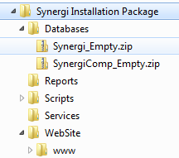

* Databases
  + Synergi_Empty.zip: contains Synergi empty database.
  + SynergiComp_Empty.zip: contains Synergi Competitor empty database.
  + Scripts: utility scripts needed during the installation process.
* Website
  + Synergi: the compiled core application website.
* Services
  + Synergi background services installer: Synergi Services Installer.msi
  + CompetitorWebServices: web services for Synergi Competitor Rates database.
  + XnHotelSystems.Synergi.CollectorEngine.Installer.msi: background services for Synergi Competitor Rates database.
* Reports: contains all SSRS reports for Synergi.

# Installation Steps

## Database Installation

* Restore the empty Synergi database:
  + Extract file Synergi_Empty.zip to have Synergi_Empty.bak file.
  + Restore database from Synergi_Empty.bak file, name the database “Synergi”.
  + Run _00_Synergi_Structure.sql. This will create the default user/login “synergiuser” as an owner for the database.
  + Open _01_Synergi_Jobs.sql, find and replace @owner_login_name=N'YOURDOMAIN\ADMIN_USER' with a local administrator account who has permission to run jobs in SQL Server Agent, then run the script.
* Restore the empty SynergiComp database:
  + Extract file SynergiComp_Empty.zip to have SynergiComp_Empty.bak file.
  + Restore from SynergiComp_Empty.bak file, name the database “SynergiComp”.
  + Run _09_SynergiComp_Structure.sql. This will create the default user/login “synergiuser” for the database SynergiComp.

## Database Configuration

* TBD

## Website Installation

* Deploy compiled website (www folder) to IIS server as an asp.net 4.0 application (set application pool is in Integrated mode for IIS 7).
* Make sure Default.aspx is in the list of default start pages.
* Provide “write” permission to the folder /Logs to “NetworkService” account.
* Open web.config file and change following parameters:
  + Find “connectionStrings” element and replace the connection string by appropriate connection string:

<add

name="TimeClock"

connectionString="data source=YourComputerName\SQL2008R2InstanceName; initial catalog=Synergi; User ID=synergiuser; Password=synergipassword"

providerName="System.Data.SqlClient" />

* + Find “mailSettings” element and replace by the appropriate SMTP server information:

<system.net>

<mailSettings>

<smtp

deliveryMethod="Network"

from="no_reply@youremaildomain.com ">

<network

host="10.10.0.7"

enableSsl="false"

userName=""

password=""

port="25" />

</smtp>

</mailSettings>

</system.net>

* + Configure report information:
    - ReportServerUrl: must be an accessible url from the end users.
    - ReportUsername/ReportPassword: the user who has the Browser right in the report server.
    - ReportDomain: the domain if the ReportUsername is a domain user, otherwise leave it blank.

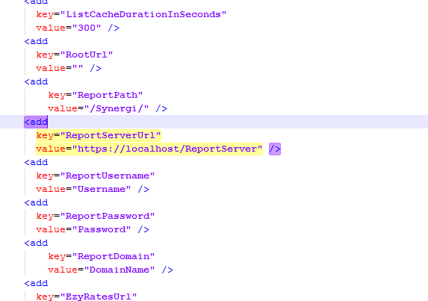

* Go to <WebsiteRoot>/ClientBin folder, extract the file Rockford.TimeClock.Silverlight.UI.xap to a new folder. In that folder:
  + Open the file ServiceReferences.ClientConfig, find and replace <http://SynergiDomain:port> by the synergi site domain / public ip.
  + Find and replace <http://SynergiCompDomain:port> by CompetitorWebServices domain / public ip.
  + Select all files in the folder and zip it to Rockford.TimeClock.Silverlight.UI.zip, then rename the extension to Rockford.TimeClock.Silverlight.UI.xap.
  + Put the new file Rockford.TimeClock.Silverlight.UI.xap back to ClientBin folder, then delete the new folder we’ve just worked.
* Open the website url in browser, use following information to login to the site and make sure the Silverlight application can load and run successfully (you will see the black theme).
  + Organisation Code: *org001*
  + Username: *PortalAdmin*
  + Password: p

## CompetitorWebServices Installation

* Deploy compiled website (\Services\CompetitorWebServices folder) to IIS server as an asp.net 4.0 application (set application pool is in Integrated mode for IIS 7).
* Open web.config file and change following parameters:
  + Find “connectionStrings” element and replace the connection string by appropriate connection string:

<add

name="SynergiCompetitor"

connectionString="data source=YourComputerName\SQL2008R2InstanceName; initial catalog=SynergiComp; User ID=synergiuser; Password=synergipassword"

providerName="System.Data.SqlClient" />

* Open the competitorwebservices url in browser to check if the webservices is installed correctly (as the following picture)

http://YourCompetitionWebservicesDomainOrPublicIP/AuthenticationService.svc

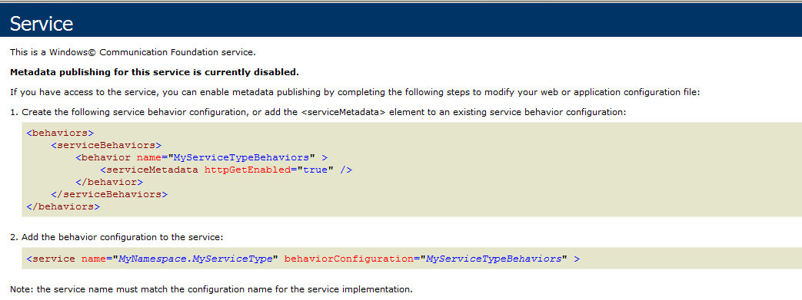

## Background Services Installation

* Run the file Synergi Services Installer.msi and follow the screens to complete installing the background services for Synergi.
* By default the service will be installed at *C:\Program Files (x86)\Xn Hotel Systems\Synergi Background Services*.
* Go to destination folder, in that folder open file *XnHotelSystems.Synergi.BackgroundServices.exe.config* and change connection string:

<add

name="TimeClock"

connectionString="data source=YourComputerName\SQL2008R2InstanceName; initial catalog=Synergi; User ID=synergiuser; Password=synergipassword"

providerName="System.Data.SqlClient" />

* Replace the publisher folder:

<publisher

publisherDllFolder="C:\Program Files (x86)\Xn Hotel Systems\Synergi Background Services\Publishers"

... />

* Register and start the service by running *install.bat*. (should run by administrator role)

## Background Services Upgrade

* Open destination folder, Stop and unregister the current service by using *uninstall.bat*.
* Follow steps in “Background Services Installation”.

## CompetitorEngine Installation

* Run the file *XnHotelSystems.Synergi.CollectorEngine.Installer.msi* and follow the screens to complete installing the background services for SynergiComp.
* By default the service will be installed at *C:\Program Files (x86)\Xn Hotel Systems\Synergi Competitor Services*.
* Go to destination folder, in that folder open file *XnHotelSystems.Synergi.* CollectorEngine*.exe.config* and change the endpoint address:

<system.serviceModel>

<client>

<endpoint address="http://YourCompetitionWebservicesDomainOrPublicIP/CollectorService.svc"

binding="basicHttpBinding" bindingConfiguration="BasicHttpBindingWithTimeouts"

contract="CollectorService.CollectorService" name="BasicHttpBinding_CollectorService" />

</client>

</system.serviceModel>

* Register and start the service by running *install.bat*. (should run by administrator role)

## CompetitorEngine Upgrade

* Open destination folder, Stop and unregister the current service by using *uninstall.bat*.
* Follow steps in “CompetitorEngine Installation”.

## SSRS Reports Installation

* In Internet Explorer, browse to the following:

[http://YourSSRSServerDomain/Reports<_SQLServerInstanceName> /Pages/Folder.aspx](http://YourSSRSServerDomain/Reports%3c_SQLServerInstanceName%3e/Reports/Pages/Folder.aspx)

where SQLServerInstanceName is the db instance which installed SSRS database.

Or you can get this link from Reporting Services Configuration Manage

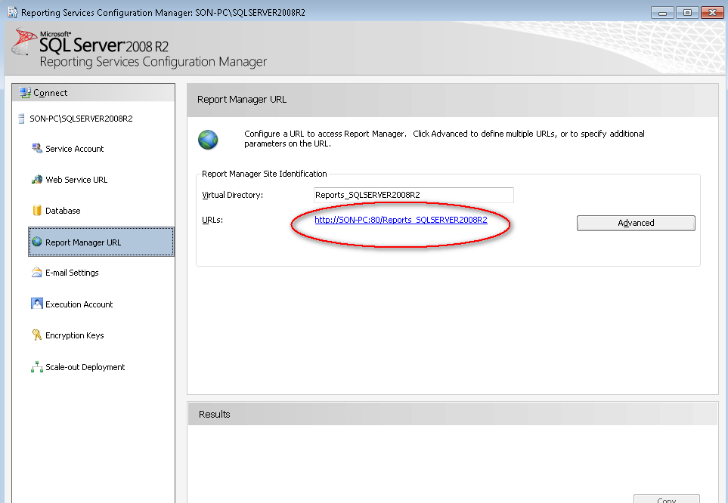

* Add the following two folders into root
  + “Data Sources”
  + “Synergi”
* Inside “Data Sources” add a new data source
  + Name: Synergi
  + Connection String: data source=; initial catalog=Synergi;
  + Credentials stored securely in the Report Server: synergiuser/synergipassword
* Inside “Synergi”, open Reports folder in InstallationPackage, upload all rdl files from the disk folder to SSRS.
* For each uploaded report, ensure the report is pointing at the data source just created.

Make sure report information has been configured at Website Installation step.